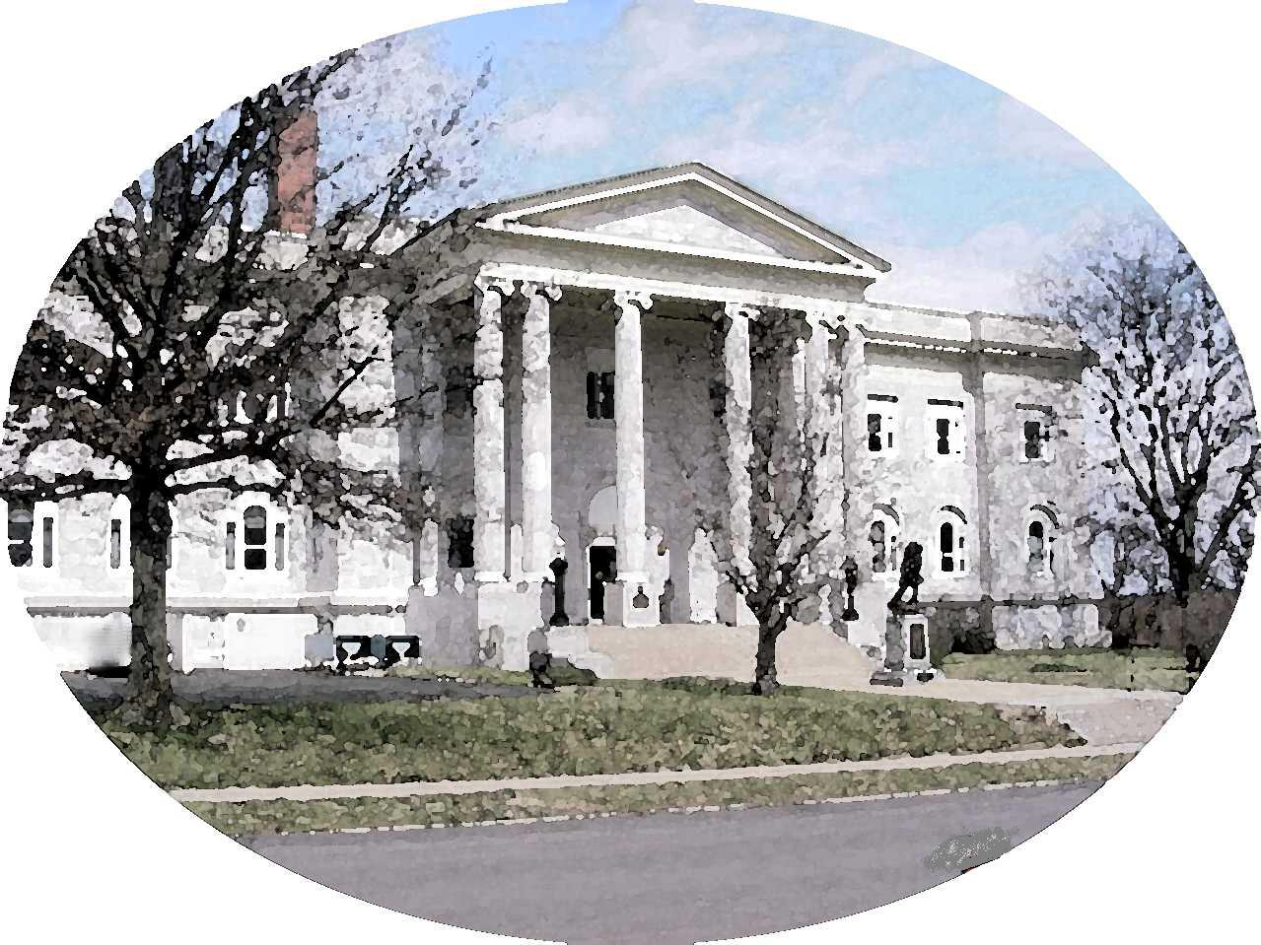

COUNTY OF LEAVENWORTH

300 Walnut St – Suite 105
Leavenworth, Kansas 66048
(913) 684-0430
Fax (913) 684-0436

___________________________________ OWNER’S NAME

_______________________________________ STREET ADDRESS; APT NO.

_______________________________________ CITY, STATE, ZIP

AFFIDAVIT TO WAIVE MILITARY EXEMPTION

STATE OF KANSAS )
)
COUNTY OF LEAVENWORTH )

I, ______________________________________, being first duly sworn, on oath, depose and say that:
- That I am in the active military service of the United States, and have/has been stationed at _______________________________ since ______________________, pursuant to military orders, and presently living at ________________________________________________.
- That I am not a resident of the State of Kansas, but I am a resident of _____________________.
- That I request to pay personal property tax on the vehicle described: Make: _______;
Year: ___________; VIN #__________________________________.
- That I fully understand that there will be no refund given in this amount paid: $_____.

___________________________________
Signature of Taxpayer

